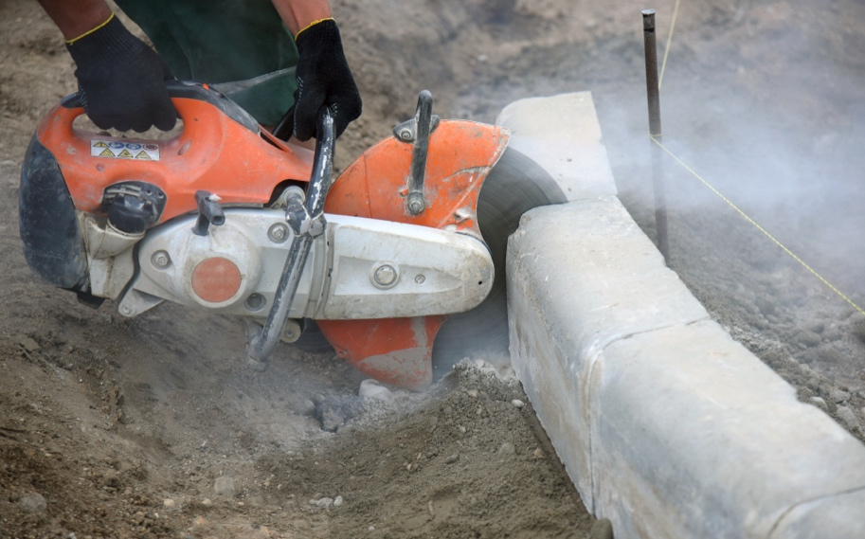
Instructions for Workers:
All workers involved in operating the Concrete Core Cutter must read, understand, and follow this Safe Operating Procedure.
If there are any questions or concerns, workers should consult their supervisor or the designated authority before proceeding.

Procedure:
Objective: The objective of this Safe Operating Procedure is to provide guidelines for the safe operation of the Concrete Core Cutter. It aims to minimize the risk of accidents, injuries, and damage to equipment and property.
Scope: This procedure applies to all workers involved in operating the Concrete Core Cutter at the designated worksite.
Hazards: The following hazards may be associated with the operation of the Concrete Core Cutter:
- Risk of contact with rotating blades or cutting mechanisms.
- Noise exposure.
- Vibration from the machine.
- Risk of airborne dust or debris.
- Potential for electrical hazards.
- Risk of slips, trips, and falls.
Risks: Failure to follow the Safe Operating Procedure can result in the following risks:
- Serious injuries, such as cuts, lacerations, or amputations.
- Hearing damage or loss.
- Vibration-related injuries.
- Respiratory problems due to dust inhalation.
- Electric shock or electrocution.
- Falls from height or other accidents.
Controls: To mitigate the hazards and associated risks, the following controls must be implemented:
- All workers operating the Concrete Core Cutter must receive appropriate training on its safe use.
- Personal Protective Equipment (PPE) should be worn at all times, including safety goggles, hearing protection, gloves, and respiratory protection.

- Ensure the Concrete Core Cutter is in good working condition, properly maintained, and inspected before each use.
- Follow manufacturer's instructions and specifications for the safe operation of the Concrete Core Cutter.
- Erect barricades or warning signs to prevent unauthorized access to the work area.
- Maintain a safe distance from rotating blades or cutting mechanisms.
- Use a dust extraction system or wet cutting techniques to minimize airborne dust.
- Ensure the Concrete Core Cutter is properly grounded to prevent electrical hazards.
- Implement procedures to prevent slips, trips, and falls, such as keeping the work area clean and free of obstacles.
- Regularly monitor and assess the effectiveness of the controls to identify and address any shortcomings.
Responsibilities: The following responsibilities are assigned to ensure the safe operation of the Concrete Core Cutter:
- Management: Provide appropriate training, resources, and supervision to workers operating the Concrete Core Cutter. Ensure compliance with this Safe Operating Procedure.
- Supervisor: Ensure workers are trained, competent, and have the necessary PPE. Oversee the safe operation of the Concrete Core Cutter and enforce compliance with this procedure.
- Workers: Comply with this Safe Operating Procedure, use appropriate PPE, report hazards or incidents promptly, and participate in training and awareness programs.
Procedure:
Always:
- Wear the required PPE, including safety goggles, hearing protection, gloves, and respiratory protection.
- Inspect the Concrete Core Cutter for any visible damage or defects before each use.
- Follow the manufacturer's instructions for setting up and operating the Concrete Core Cutter.
- Ensure the work area is clear of debris and obstructions.
- Securely fasten the workpiece to prevent movement during cutting.
- Use appropriate cutting techniques and avoid forcing the blades or cutting mechanisms.
- Monitor the equipment during operation for any unusual noises, vibrations, or malfunctions.
- Shut off the Concrete Core Cutter and disconnect from the power source after use.
- Properly store the Concrete Core Cutter in a designated area.
Never:
- Operate the Concrete Core Cutter without the required PPE.
- Use the Concrete Core Cutter if it is damaged or defective.

- Exceed the maximum cutting capacity of the machine.
- Attempt to remove or adjust blades or cutting mechanisms while the equipment is running.
- Use the Concrete Core Cutter in wet or damp conditions without appropriate precautions.
- Use the Concrete Core Cutter near flammable materials or in explosive atmospheres.
Weather: Consider weather conditions when operating the Concrete Core Cutter. Avoid operation in severe rain, high winds, or other adverse weather conditions that may affect safety.
Environment: Ensure the work area is properly ventilated to minimize the risk of dust inhalation. Take precautions to protect nearby personnel and bystanders from dust, debris, and noise generated by the Concrete Core Cutter.
Housekeeping: Maintain a clean and organized work area. Regularly remove debris, waste materials, and dust generated during operation. Store tools and equipment properly when not in use.
Review: This Safe Operating Procedure for the Concrete Core Cutter should be reviewed periodically to ensure its continued effectiveness. Any necessary updates or improvements should be made based on feedback, incidents, or changes in regulations or equipment.
Monitoring: Supervisors or designated personnel should monitor the implementation of this Safe Operating Procedure to verify compliance and identify areas for improvement. Regular inspections of equipment and work areas should be conducted to ensure adherence to safety standards.
Employees' Acknowledgment and Understanding:
I acknowledge that I have read and understood the Safe Operating Procedure for the Concrete Core Cutter. I understand my responsibilities and obligations outlined in this procedure. I will comply with the procedures and safety controls to ensure the safe operation of the Concrete Core Cutter. I will report any hazards, incidents, or concerns promptly to my supervisor or the designated authority.
Signed: _____________________ Date: _____________________

