Business name:
Project location:
Contact person:
JSA Authorised by:
Position:
Authoriser signature:
Date authorised:
Work activity: | What type of work will you be doing?
Who are involved in the activity:
Personal protective equipment:

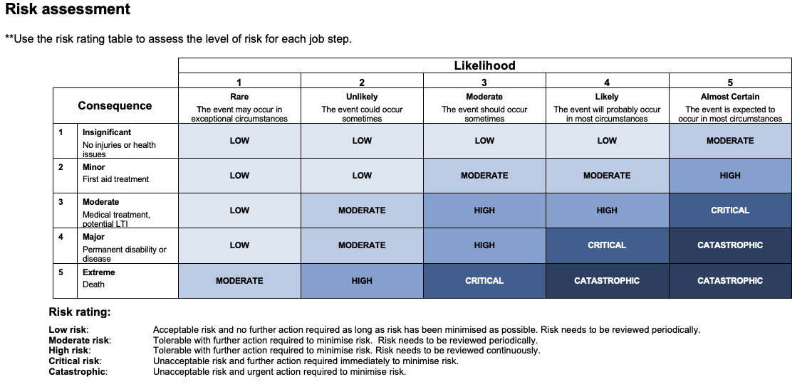

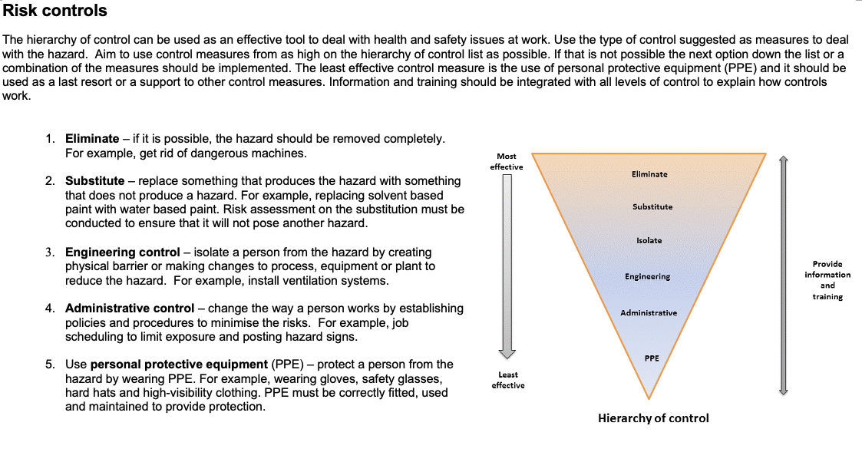

Step  No. | Job step details | Potential hazards | Risk  Rating | How to control risks | Residual  Risk | Person responsible

This JSA has been developed through consultation with workers and has been read, understood, and signed by all workers undertaking the works:
Name: | Signature: | Date:

