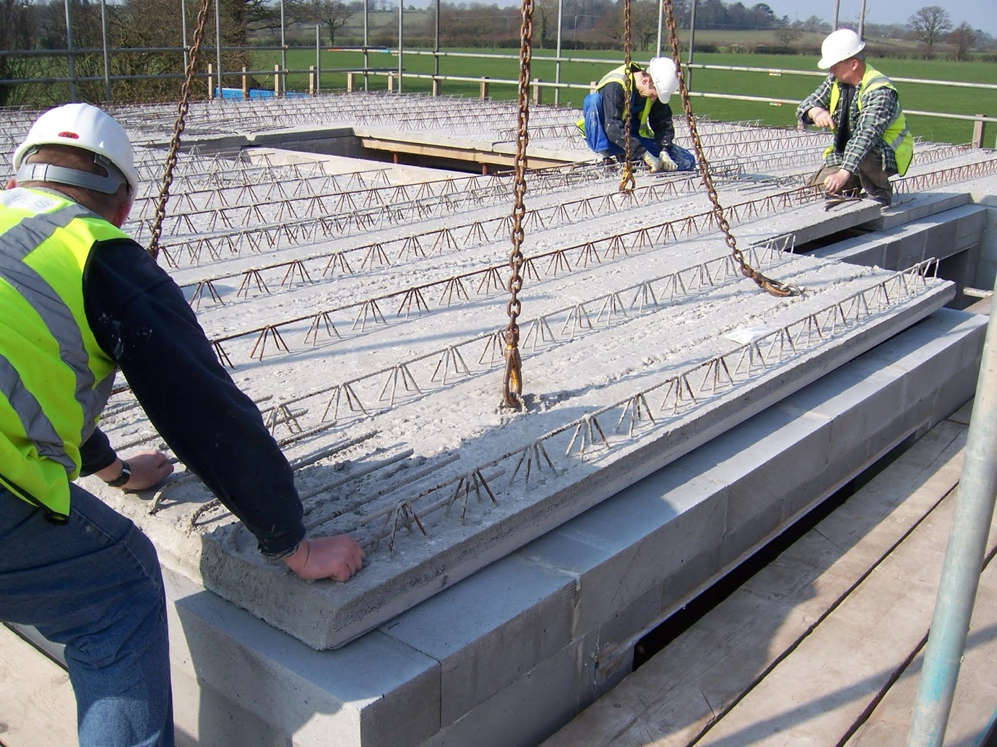
Standard Operating Procedure (SOP) for Rigging Concrete panels

Objective: To safely rig concrete panels for lifting and installation in accordance with relevant safety regulations and best practices.
Preparation:
- Review Plans and Procedures:
  - Review construction plans and lifting procedures specific to the project.
  - Familiarise yourself with the weight, dimensions, and lifting points of the concrete panels.
  - Identify any potential hazards or obstacles in the lifting area.
- Inspect Equipment:
  - Ensure all lifting equipment, such as cranes, hoists, slings, shackles, and spreader bars, are in good working condition and rated for the load.
  - Perform pre-use inspections according to manufacturer's instructions and regulatory requirements.
  - Check for any defects, damage, or wear that may compromise safety.
- Select Proper Rigging Equipment:
  - Choose appropriate lifting slings or straps based on the weight, shape, and lifting points of the concrete panels.
  - Ensure that the rigging equipment is rated for the anticipated load and complies with relevant standards.

Rigging Procedure:
- Position the Lifting Equipment:
  - Position the crane or hoisting equipment in a stable location that provides adequate clearance for lifting and manoeuvring the concrete panels.
  - Follow proper setup procedures outlined in the equipment's operation manual.
- Attach Rigging Equipment:
  - Securely attach lifting slings or straps to the designated lifting points on the concrete panels.
  - Use appropriate rigging techniques, such as choke hitches or basket hitches, to evenly distribute the load and prevent slippage.
  - Avoid placing rigging equipment over sharp edges or corners that may cause damage or failure.
- Verify Load Stability:
  - Confirm that the rigging configuration provides a stable and balanced lift.
  - Perform a visual inspection of the rigging setup to ensure proper alignment and tension.
  - Adjust the rigging as needed to minimise sway or movement during lifting.
- Communicate and Coordinate:
  - Establish clear communication channels with the crane operator and ground personnel involved in the lifting operation.
  - Use standardised hand signals or radio communication to coordinate movements and ensure safe lifting procedures.
- Lift and Manoeuvre the Panels:
  - Gradually lift the concrete panels using smooth and controlled movements.
  - Avoid sudden or jerky motions that could destabilise the load.
  - Monitor the lifting operation closely and adjust as necessary to maintain stability.
- Position and Secure Panels:
  - Position the concrete panels accurately in accordance with the construction plans and specifications.
  - Use guide ropes or tag lines to control the descent and placement of the panels.
  - Securely fasten the panels in place using appropriate anchors, connectors, or temporary supports.
Post-Operation Checks:
- Inspect Rigging Equipment:
  - Inspect lifting slings, straps, shackles, and other rigging hardware for any signs of damage or wear.
  - Remove damaged equipment from service and replace as necessary.
- Document and Report:
  - Document any incidents, near misses, or safety concerns related to the rigging operation.
  - Report any equipment malfunctions or deficiencies to the appropriate personnel for corrective action.
- Review and Evaluate:
  - Conduct a post-operation debriefing to review the effectiveness of the rigging procedures and identify areas for improvement.
  - Incorporate lessons learned into future rigging plans and procedures.

Additional Considerations:
- Always follow applicable safety regulations, industry standards, and manufacturer's guidelines when rigging concrete panels.
- Ensure that all personnel involved in the rigging operation receive proper training and certification for their respective roles.
- Monitor weather conditions and other external factors that may affect the safety of the lifting operation.
- Implement a clear chain of command and emergency response procedures in case of accidents or unforeseen events.

SOP REFRESHER TRAINING WORKSHOP
Date:
Location:

I confirm that I have undergone thorough training in the Safe Operating Procedure (SOP) for rigging concrete panels. I understand my responsibilities and the potential hazards associated with this task.
I acknowledge that rigging concrete panels requires strict adherence to safety procedures to prevent accidents. Therefore, I commit to following the guidelines outlined in this SOP diligently to ensure the safety of myself and others present during the operation.
I am fully aware of the risks involved in rigging concrete panels, including potential contact with heavy loads, the risk of equipment failure, and the dangers associated with working at height. I understand the importance of using proper lifting equipment and techniques to mitigate these risks.
Additionally, I understand the significance of wearing appropriate personal protective equipment (PPE), such as hard hats, safety gloves, and steel-toed boots, to protect against potential hazards.
Furthermore, I acknowledge the importance of inspecting rigging equipment before use and reporting any defects or damage promptly to the appropriate personnel.
By signing below, I affirm my commitment to following the Safe Operating Procedure for rigging concrete panels and ensuring the highest standards of safety are upheld at all times.

WORKSHOP ATTENDEES SIGNATURES:

