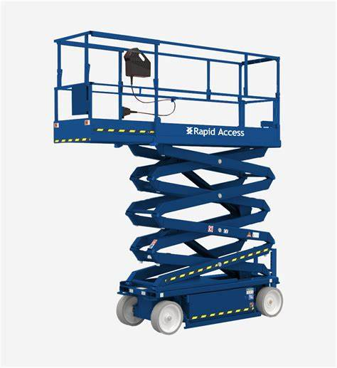

Objective: To ensure the safe operation of scissor lifts in the workplace, preventing accidents, and promoting a secure working environment.
Responsibilities:
- Operator Responsibilities:
  - Only trained and authorised personnel are allowed to operate scissor lifts.
  - Conduct a pre-operation inspection before each use.
  - Adhere to all safety guidelines and procedures outlined in this SOP.
  - Communicate any concerns or malfunctions to supervisors promptly.
  - Wear appropriate personal protective equipment (PPE) during operation.
- Supervisor Responsibilities:
  - Ensure that only trained and authorised personnel operate scissor lifts.
  - Verify that pre-operation inspections are conducted and documented.
  - Monitor compliance with safety procedures and address any violations promptly.
  - Provide necessary training and retraining as needed.
Pre-Operation Inspection:
- Check Controls:
  - Ensure that all controls are functional and respond appropriately.
  - Test emergency controls, including the stop button.
  - Address any issues with controls before operation.
- Check Hydraulic System:
  - Inspect for any visible leaks in the hydraulic system.
  - Ensure that the lift responds smoothly to control inputs.
  - Report any hydraulic issues immediately to maintenance.
- Inspect Platform and Guardrails:
  - Verify that the platform and guardrails are secure and undamaged.
  - Confirm that entry gates are functioning correctly.
  - Address any damage promptly to prevent accidents.
- Check Emergency Lowering System:
  - Test the emergency lowering system to ensure it works effectively.
  - Ensure all personnel are aware of the emergency lowering procedure.
- Inspect Tires and Wheels:
  - Check for any visible damage to tires and ensure proper inflation.
  - Verify that all wheels are in good condition.
  - Report any tire or wheel issues for maintenance.
Hazards and Risks:
- Fall Hazards:
  - Operating at heights poses a risk of falls. Always use guardrails and fall protection devices.
  - Stay within the designated work platform and never lean over the guardrails.
- Crushing Hazards:
  - Pinching and crushing hazards exist during scissor lift movement. Keep hands, feet, and clothing clear of moving parts.
  - Ensure no personnel are beneath the scissor lift during operation.
- Electrocution Risks:
  - Be aware of overhead power lines and maintain a safe distance.
  - Do not operate the scissor lift in adverse weather conditions like thunderstorms.
Dos and Don'ts:
Dos:
- Do wear appropriate PPE, including a hard hat and a safety harness.
- Do follow the manufacturer's guidelines for operation.
- Do communicate effectively with other personnel in the vicinity.
- Do use caution when driving the scissor lift, especially on uneven surfaces.
Don'ts:
- Don't exceed the designated load capacity of the scissor lift.
- Don't use the scissor lift as a crane or for any purpose other than its intended use.
- Don't override safety devices or attempt to disable any safety features.
- Don't operate the scissor lift if there are unresolved safety concerns or malfunctions.
Post-Operation Procedures:
- Shutdown:
  - Return the scissor lift to the designated storage area.
  - Turn off the power and secure the unit.
- Post-Operation Inspection:
  - Conduct a post-operation inspection and document any issues or concerns.
  - Report any defects or malfunctions to the supervisor.
  - Ensure proper storage and charging of the scissor lift.
Training: All personnel operating scissor lifts must undergo comprehensive training, including both theoretical and practical components.
Documentation: All inspections, training records, and incident reports must be documented and filed for future reference.
Review and Revision: This SOP will be reviewed periodically and revised as necessary to ensure its continued effectiveness.

I, ___________________hereby acknowledge receipt and understanding of the Safe Operating Procedure (SOP) document provided by. I affirm my commitment to adhere to the outlined procedures meticulously, ensuring the safety of myself and my colleagues. Furthermore, I acknowledge that I have undergone thorough training on the SOP to equip myself with the necessary knowledge and skills to execute tasks safely and efficiently. By signing this acknowledgment, I affirm my dedication to maintaining a secure work environment and contributing to the overall safety culture of the business.

Workers Signature:

Date:

